1. **Agenda:**
   1. We will make Kafka Producer Transfer MS send both Kafka Messages (Withdraw and Deposit) in a single Transaction.
2. 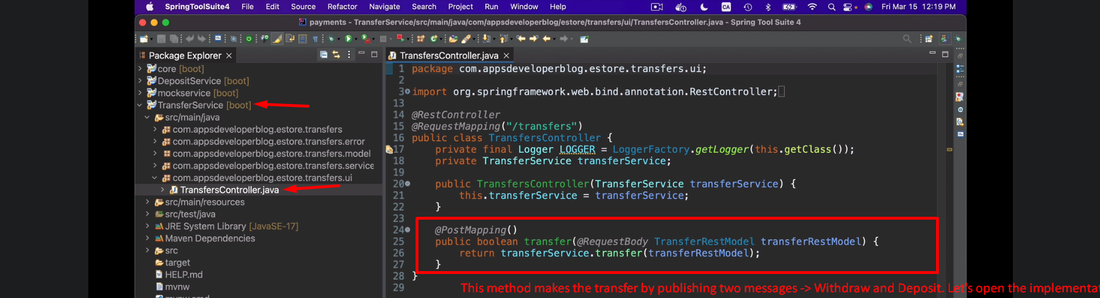
3. 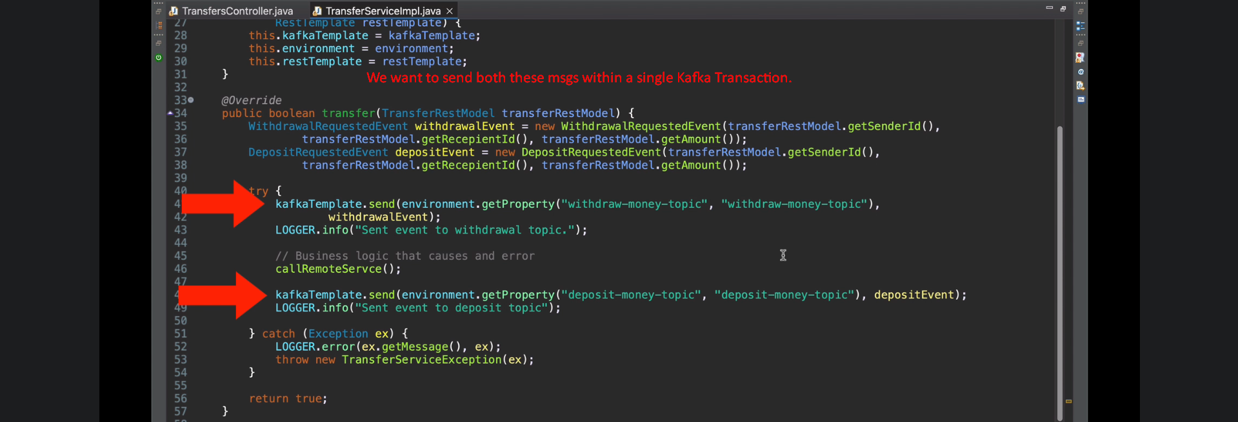
4. 